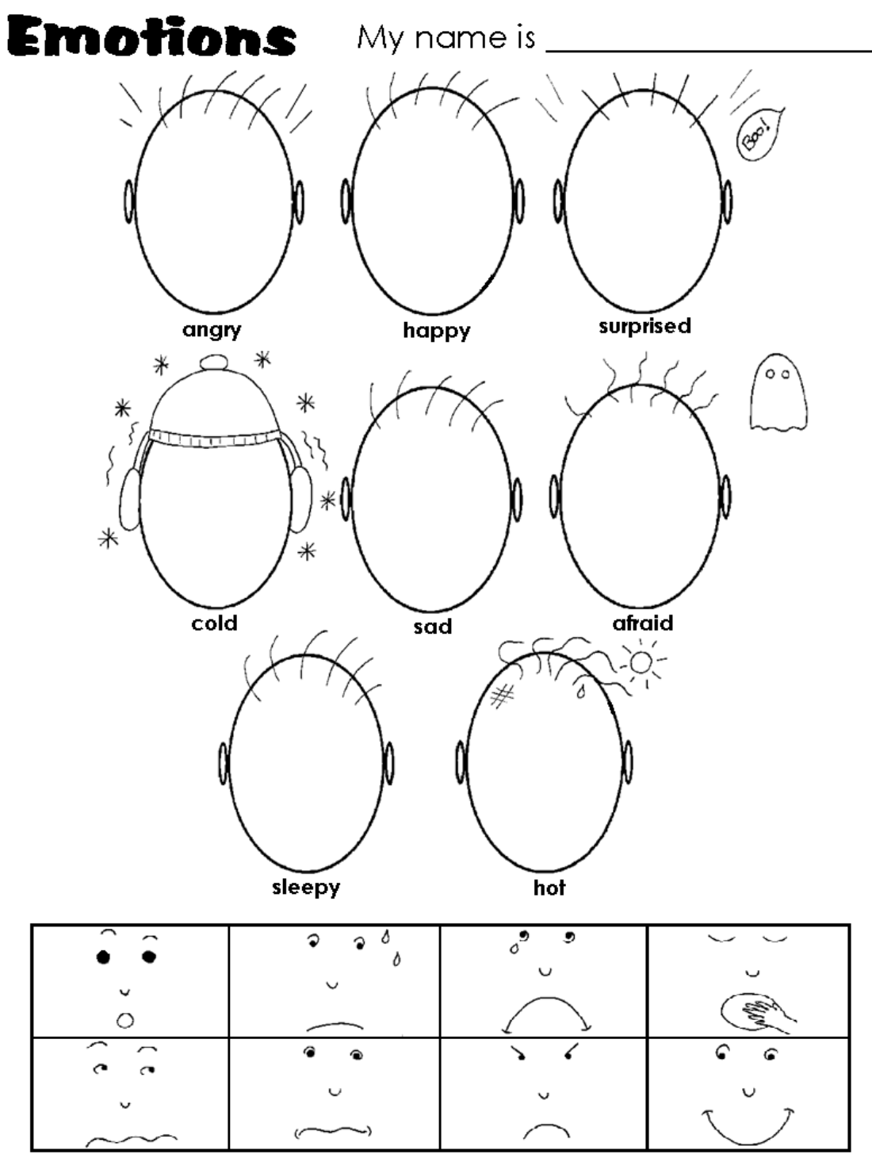

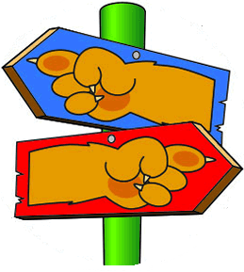
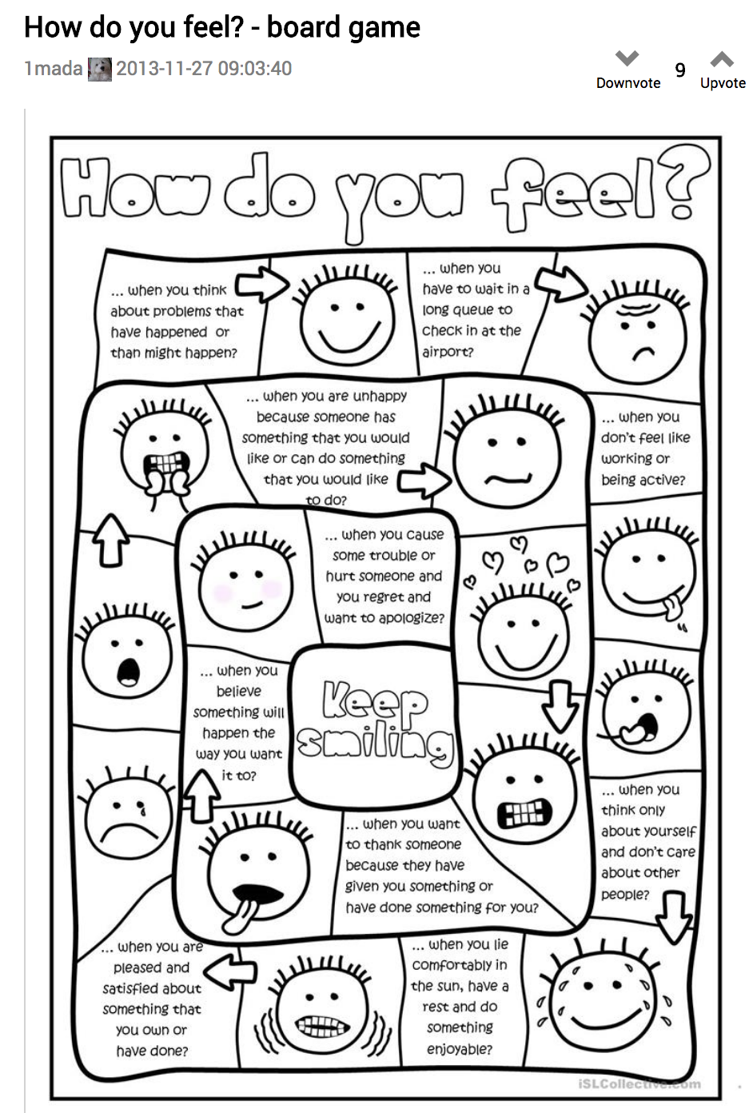Pick My Path – Materials Needed

Parent and Leader Guidebook: pages 71-75
Lion Adventure Book: pages 15 and 19

Materials
- Copies of Pick My Path handout, one per adult
- Copy of Den Meeting Plan, one for leader(s)
- Name tags and Sharpie
- Cub Scouts Poster Set with Scout Law, Scout Oath and Den Code of Conduct
(#621086 from Scout Shop)
- Blue tape or something to hang posters on wall

Optional
- Snack and water
- Activities for siblings (e.g., coloring books)

Gathering: Hold/Cold Game
- Object hidden before meeting

Activity 1: Emotion Charades
- Printed emotion pictures, one copy cut apart

Activity 2: Pick My Path
- Few extra copies of Lion Adventure Book page 15 and 19 (for those who forget book).
- Colored pencils, crayons or markers (two colors; color four pieces in one color and four in the other)
- Scissors, one per Scout

Den Meeting Plan
Pick My Path
Gathering
- Hot/Cold Game
Opening
- Good conduct candle, pledge, Scout Oath, Scout Law
Talk Time
- Den business
- Sharing time
- What is a friend?
- Are your friends the same age as you, or are some different ages?
- What does a friend do?
- Have you ever been mad at your friend? It is IK to feel mad at your friend? How did you make the situation better?
- Has your friend ever been mad at you? How did this make you feel? How did you fix this situation?
- Assign Homework: Do one kind thing for a member of your family or a friend.
Activities
- Activity 1: Emotion Charades (page 73)
- Before: Sometimes we know how someone is feeling without them saying a word. We can look at what their body is doing and figure it out. This is called body language or nonverbal cues. The adults will pick an emotion and demonstration through nonverbal cues. Lions choose the emotion they think they are seeing.
- After: Ask Lions: Have you ever felt any of these emotions? Did your body tell the story to someone How long did you feel that way – 1 min? 5 min? Longer?
- Emotions are like flying animals – they fly to us, stay for just a short time, then fly away. The most important thing to remember is that feelings are always OK, but we must be aware of how we react. Some reactions are not OK (e.g., if we are angry, we must not hit anyone). Only we can choose how to respond to our feelings. It is our path to pick.
- Activity 2: Pick My Path (instructions: page 73)
Step 1: Color game piece on Lion Adventure Book, page 19 – need two colors: color four pieces in one color and four in another color
Step 2: Use Lion Adventure Book, page 15 to play tic tac toe – switch up partners
After: Ask the Lions if their choice of where to place their lion paws helped them win or lose the game. Have them share how our decisions can affect what happens to us. (e.g., if we don’t brush our teeth, we get cavities which will cause us pain or if we leave our bike it will rust or might get run over by parents in driveway).
- Activity 3: Games (page 57)
Hide and Seek Bandage Tag Tag Rock, Paper, Scissors
Closing
- Scout Law. Leader reflect on one of the points of Scout Law: Kind. Ask Lions to give examples of when they were kind.

Pick My Path Adventure

Home Assignment:
Do one kind thing for a member of your family or a friend.

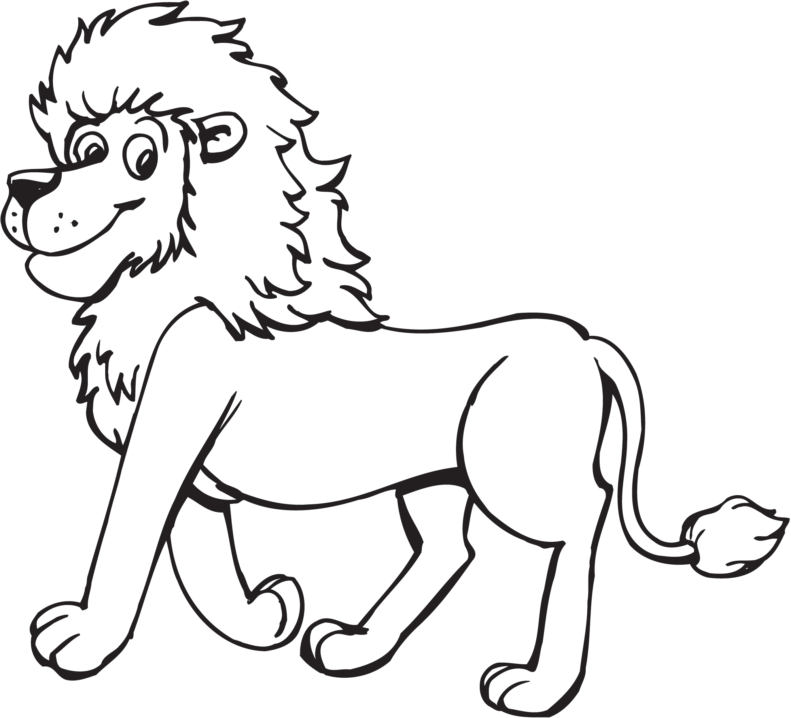

Scout Law
A Scout is trustworthy, loyal, helpful, friendly, courteous, kind, obedient, cheerful, thrifty, brave, clean, reverent.
Scout Oath
On my honor, I will do my best to do my duty to God and my country and to obey the Scout Law; to help other people at all times; to keep myself physically strong, mentally awake, and morally straight.
Upcoming Events

Feb 23 – Check in Pinewood Derby car
Feb 24 Pinewood Derby
Feb 28 Pack Meeting
Mar 7 Den Meeting
Mar 24-25 Family Campout, optional
April 4 Den Meeting at Spring Creek Park
April 14 Scout Fair at NRG, optional
www.shac.org/scout-fair
May 2 Den Meeting at TBD
May 19 Pack Meeting / Banquet
June 12-15 Twilight Camp, recommended
(orion.shac.org/day-camp)

Pack 72
facebook.com/pack72tomball
pack72tomball.scoutlander.com
Orion District
www.orion.shac.org
facebook.com/orionbsa
Sam Houston Area Council
www.shac.org
facebook.com/shac.bsa
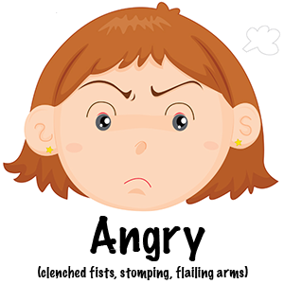 | 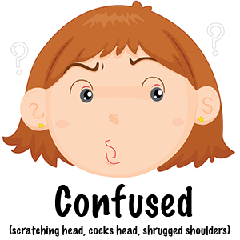 | 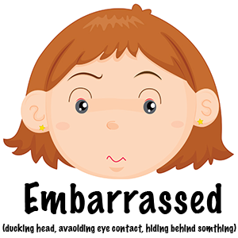
 | 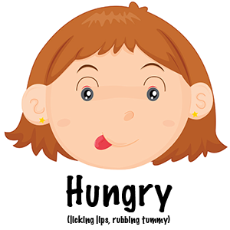 | 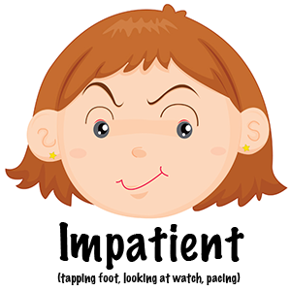
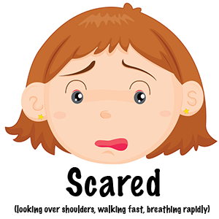 | 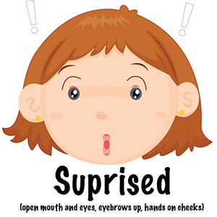 | 